**WEB DEVELOPMENT ISSUES I & II**

**ASSIGNMENT**

**GROUP MEMBERS**

CHUKWU DANIEL NONSO BHU/20/04/05/0010

Aromolaran Adenike Elizabeth BHU/20/04/05/0136

ADAMS OJIMA LUCKY BHU/21/04/05/0097

OCHENI TIMOTHY OJIMAOJO BHU/20/04/05/0106

IWUANYANWU LOTANNA CHUKA BHU/21/04/05/0014

**QUESTIONS**

**Web Development Issues I**

There are so many issues with web development, implementation, deployment and usage. Describe an issue (challenge) and discuss how the issue can be solved (use code snippets/web views to explain the challenge and mitigation method). Submit in groups of 5. There will be presentation.

**Web Development Issues II**

There are many process models that are adaptable in implementing software engineering projects. Use your knowledge of web characteristics and of software process models to argue whether or not a model (selected by your group) is suitable for web features, and adjust the model in question to suite web application development.

NOTE: You are to describe with the aid of the diagram the process model in question and the new (adjusted) model.

# Web Development Issues I: Version Control Conflicts

Version control conflicts occur when multiple developers make changes to the same part of the codebase simultaneously. These conflicts can lead to issues during the merging process, where the version control system (VCS) cannot automatically reconcile the differences between the changes.

**Example Scenario:**

Two developers, Alice and Bob, are working on the same file in a Git repository. Alice modifies a function to add new functionality, while Bob fixes a bug in the same function. When they try to merge their changes, a conflict occurs.

**Conflict Example:**

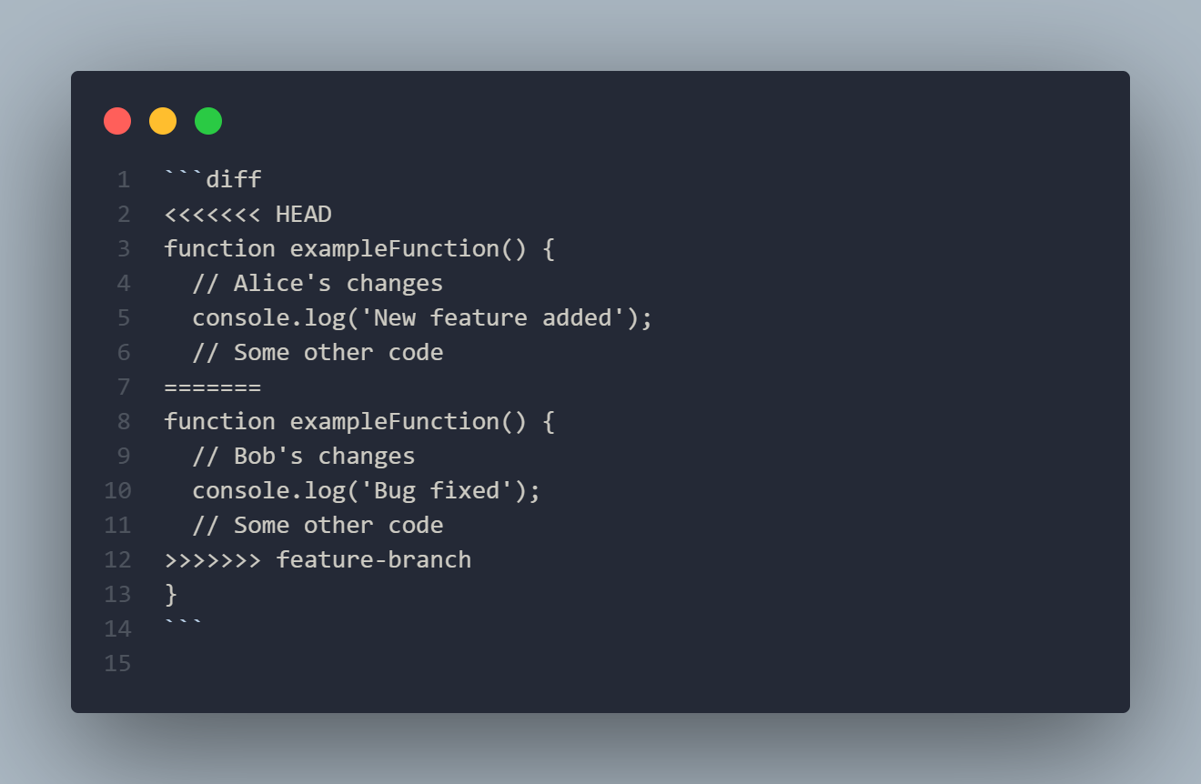

**Solution:**

To solve version control conflicts, follow these steps:

**1. Communicate and Coordinate:** Developers should communicate their changes and coordinate work to avoid conflicts.

**2. Pull Changes Frequently:** Regularly pull changes from the main branch to stay up-to-date with others' work.

**3. Use Branching Strategies:** Adopt branching strategies like Git Flow or feature branching to isolate work and reduce conflicts.

**4. Manual Resolution:** When conflicts occur, manually resolve them by editing the conflicting code to incorporate both sets of changes.

**Manual Conflict Resolution:**

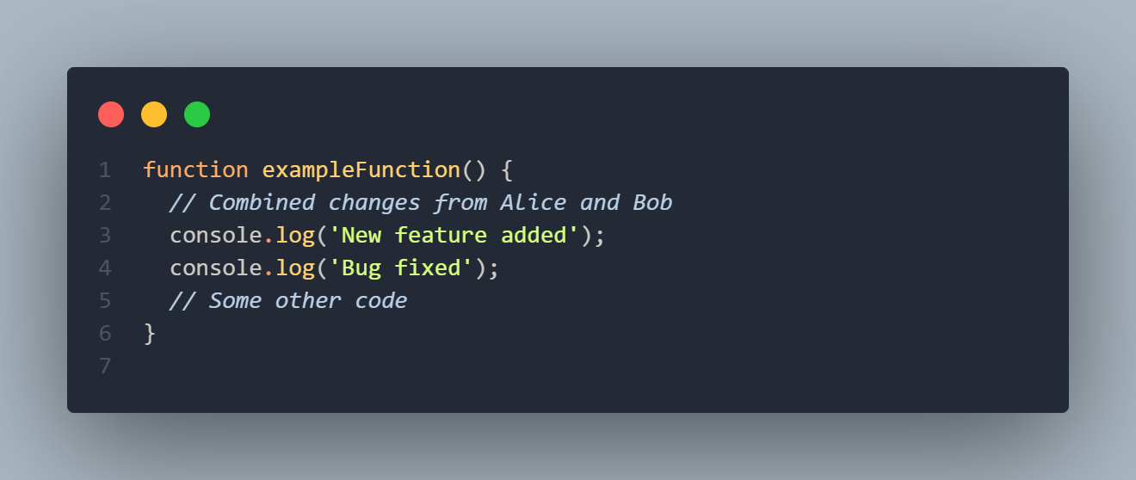

**Web View (Visual Example):**

To visualize this, a web interface can be used where conflicts are displayed and resolved:

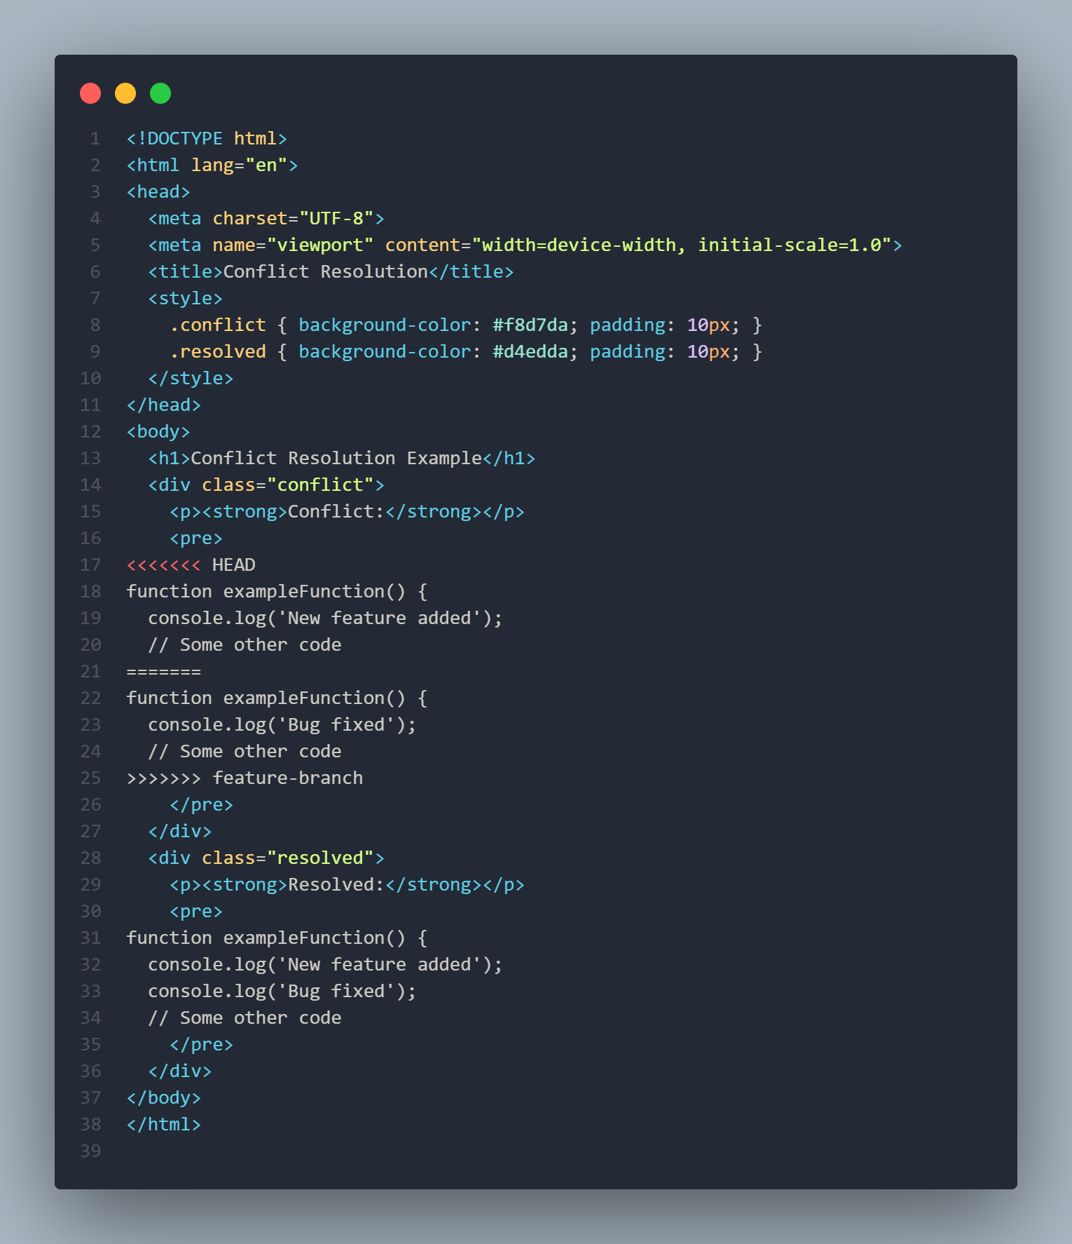

# 2. Web Development Issues II: Suitability of the Waterfall Model for Web Development

**Original Waterfall Model:**

The Waterfall model is a linear and sequential approach to software development. Each phase must be completed before the next begins. This model is suitable for projects with well-defined requirements that are unlikely to change.

**Diagram of the Original Waterfall Model:**

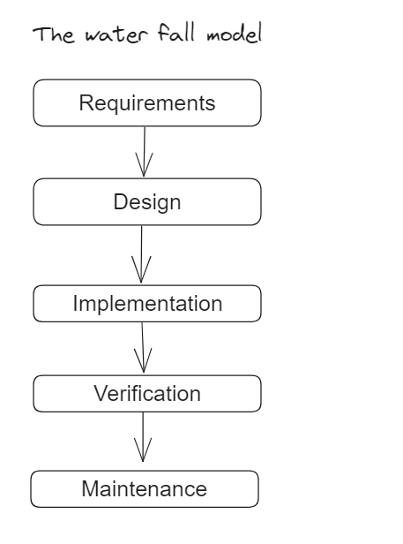

**Argument for Suitability:**

The Waterfall model is often criticized for its inflexibility and lack of responsiveness to changing requirements, which are common in web development projects. Web applications frequently need to adapt to new technologies, user feedback, and evolving requirements.

**Adjusted Model: Agile Model for Web Development:**

The Agile model, with its iterative and incremental approach, is more suitable for web development. Agile allows for continuous feedback, adaptation to changing requirements, and incremental improvements.

**Diagram of the Adjusted Agile Model:**

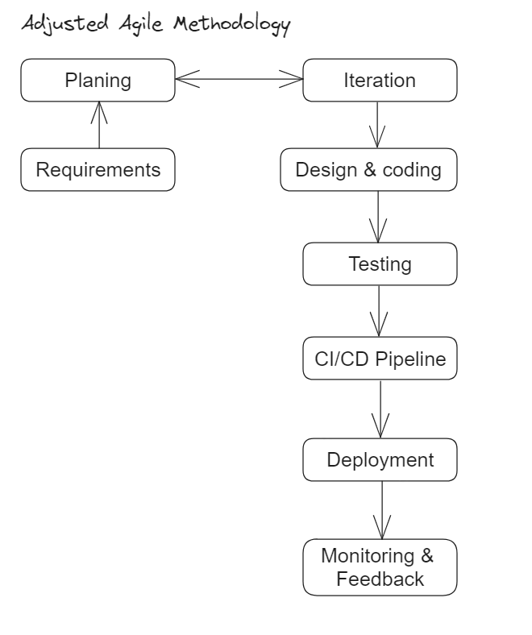

**Explanation of Adjustments:**

**- Iteration:** Dividing the project into smaller iterations allows for regular delivery of functional parts, enabling early feedback and adaptation.

**- CI/CD Pipeline:** Continuous integration and deployment ensure that changes are automatically tested and deployed, reducing manual errors and speeding up the release process.

**- Monitoring & Feedback:** Continuous monitoring of the application in production and incorporating user feedback help improve the application iteratively.

These adjustments make the Agile model better suited for the dynamic nature of web application development, ensuring that the project can adapt to changing requirements and deliver value incrementally.